Title: | BANKAL PLAZA OPERATING GUIDELINES |  |  | Effective Date: | 15 October 2019
Title: |  |  |  | Original Date: | 24 September 2016
Rev No. | Date | Originator | Revision History
1.0 | 24 Sept 2016 | R. Montayre | - Origination  - Transfer to new template  - Change policy # from FCCMPC-02-2014 to FC-BD-003
2.0 | 23 June 2017 | R. Montayre | - Incorporate applicable forms  - Add new procedure  Why Was Change Made?  - Update policy in response to OFI stage 2 audit
3.0 | 25 Sept 2019 | R. Montayre | - Updated procedure to cover special monthly rent for special accommodation and requests. Para 13.8  - Re-stablished Bankal Property Custodian role vs property custodian /Technical Supervisor. Para 6.1  - Updated collection provision for late payments. Para 14.1.10

- PURPOSE & OBJECTIVE
  - To establish and provide an over-all guideline for the operation procedures and practices to be enforced in the Bankal Plaza business
  - Develop a uniform guideline for execution among employees and contract services for the Bankal Plaza

- SCOPE
  - This procedure is applicable to the Bankal plaza operations and its businesses

- POLICY STATEMENT
  - It is the policy of FCCMPC officers and management to develop and adhere to highest standards of professionalism in the conduct of services to members and customers in accordance to existing work ethics, policies and compliance to the prescribed laws and regulations set forth by the cooperative development authority and partner government agencies and cooperative federations.
  - It is likewise the policy of FCCMPC to implement best effort for environmental protection and environmental deterioration prevention

- ORGANIZATION
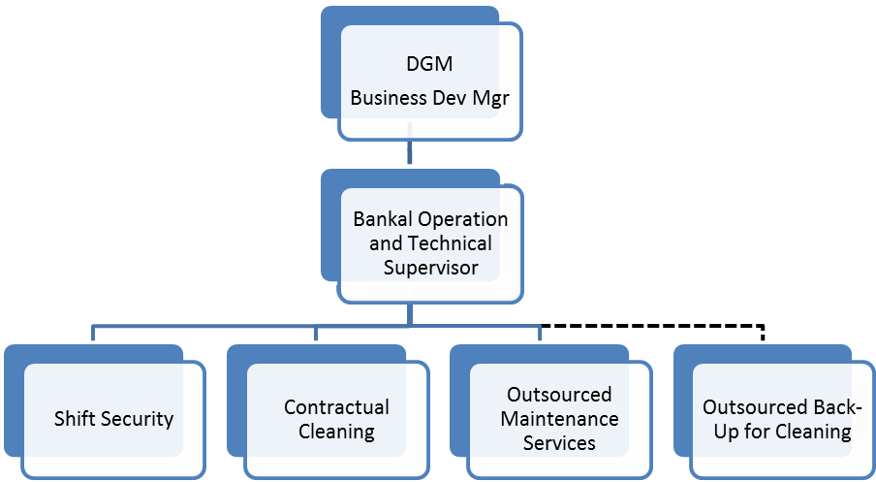

- APPLICABLE FORMS / DOCUMENTS
  - Guest Registration Form Attachment 1
  - Bankal Plaza Room Check-out Checklist Attachment 2
  - Bankal Plaza Daily Cleaning Checklist Attachment 3
  - Room Cleaning Checklist Attachment 4
  - Collection Procedure for FCCMPC Business Facilities Attachment 5
  - Corrective Action Request Attachment 6
  - Quarterly Preventive Maintenance Attachment 7
  - Periodic / Monthly Rental Contract Attachment 8

- ROLES AND RESPONSIBILITIES
  - Bankal Operation Property Custodian
    - Official information provider for the facility
    - Responds to queries for potential clients and customers
    - Provides contact numbers and addresses as requested
    - Inquiries for purpose of stay and duration of stay
    - All inquiries will be responded within the work days
    - Assures the rental Apartelle rooms are prepared for occupancy on a daily basis for daily rental rooms
    - Assures that regular checks are done for each rented room by maintenance team though checklist
    - Highlight potential issues and provide resolution and discuss with the DGM or Business Development manager
    - Responds to customer complaints and escalates information to the technical and business development management to assure fast and reliable actions and problem closure
    - Provides and shares weekly or daily reports to the business manager for information alignment
    - Follow though for actions on issues highlighted for action and solutions if found not done or resolved
    - Performing regular billing and collection to room renters.
  - Technical Supervisor / Property Custodian Supervisor
    - Provides technical guidelines for site execution
    - Creates a cleaning checklist for the entire facility for the Contractual Cleaner to follow and execute
    - Creates a maintenance checklist for the entire facility for utilities and surrounding
    - Creates checklist of maintenance activities for each rented room
    - Assures the execution of the maintenance checklists for the business facility on grounds and in rooms through review of checklist completions and reports
    - Conduct facility spot audits and check to ensure maintenance checklist requirements are done and executed accordingly to objectives of performance standards, functionality and reliability
    - Conduct facility visit at least 3-4 times a week
    - Helps ensure permanent resolution to problems of issues within the facility
  - Facility Contractual Cleaner
    - Performs to the daily checklist of activities and operations instructions. Executes daily cleaning of the over-all property following the checklist as to Attachment 3.
    - Prepares rental rooms for daily occupancy. Refer to Attachment 4 for the Room Cleaning Checklist.
    - Reports any observations within the facility to the property custodian / Technical Supervisor.
    - Contract work hours starts at 7:30 am and ends at 5:00 pm on a 5 day workweek
  - Shift Security
    - Wears the proper uniform at all times
    - Shift security on 12 hours work shift basis from 7 to 7 shift duration for 2 shifts
    - Checks on logs in security logbook and conduct interface and transfer of information relevant to shift watch
    - Shall use the communication mediums cell phone and land lines only for business use and not for personal use or play
    - Security gate chain should be put up all the time and shall be put down only on events and when guests or officers arrive
    - Assures consistent and continuous log of entire facility observations for any of the following in the provided security logbook:
      - Visitor entries, name, purpose of visit, time in and time out
      - Vehicle entries and exit time
      - Roving rounds observations
      - Special entries from customers or clients
      - Incident reports and log
    - Turns on and turns off all perimeter and facility lights according to schedules within 6pm to 5am
    - Turns on and off the water pump on following preferred scheduled hours and checks on the actual tank at the top floor location. This is to assure consistent water supply to guest rooms. Recommended cycle as follows:
      - Starts at 7:30 am
      - 9:30 am
      - 12:30 NN
      - 1:30 pm
      - 3:30 pm
      - 5:30 pm
      - 8:30 pm
      - 10:30 pm
      - 5:30 am
    - Conduct roving schedule around the facility at least 4 times a shift
    - Maintains a clean and presentable guard house. No hanging of clothes inside the guard house
    - There shall be no visitors allowed inside or near the guard house
    - Does not sleep on duty

- REFERENCE INFORMATION
  - The following information will be made available or monthly renters, daily clients, suppliers and visitors (or even buyers as interested) :
  - Business name : Bankal Plaza
  - Business Address : Mahayahay, Bankal Lapu-Lapu City
  - Telephone Numbers :
    - Land line : (63-32) 494 3821
    - Cell Phone : (Sun) 0942-532-6989
    - Contact Person : Business development manager, Bankal Operation and Technical Supervisor
  - Total Number of Rooms : 19 with one (1) welcome Lobby Area
  - Room Size : 34 – 36 Sq meters per room
  - Ample water supply – pressurized (elevated tanks – roof top)
  - Individual room electricity and water meters
  - Vehicle parking capacity : 20 vehicles
  - Total Land Area : 1,383 sq Meters
  - Total of 2 buildings
- CHECK-IN AND CHECK-OUT TIME
  - For Daily Use
    - Check-in : 10:00 am
    - Check-out : 12:00 nn
    - Allows for late check out upon request only up to 2:00 pm
  - Maximum headcount for each room is no more than 4 headcount. Each headcount beyond the maximum allowed headcount will add 50.00 php per head but shall not go beyond 6 people or 4 adults and 2 children or 2 adults and 4 children.
  - Fill up and sign the Bankal guest registration form
  - For Monthly renters
    - Fill up and signs Bankal guest registration form (Attachment 1) attached with a photocopy of guest’s passport or any photo-bearing identification card
    - Sign the Bankal contract of lease
    - Contract of Lease shall be notarized within 30 days from signing.
  - Visitors are allowed but shall need to log in at security guardhouse/area for safety and accounting purpose in case of emergencies or natural calamities

- PARTIES AND CELEBRATIONS
  - Parties and celebrations will require prior notice to the property custodian and/or Technical Supervisor at least 3-5 days ahead of schedule
  - In events of celebrations and parties, the cut-off time will be no more than 10:30 pm to show respect for neighbor rooms and areas. The shift security shall be the enforcing arm for this
  - Each room will be to accommodate enough headcount within the room so that there is no disturbance to neighboring rooms or in the facility. Number of heads shall not be beyond 10 per such event or celebration

- CHECK-IN PROCESS / PROCEDURES
  - Complete the information sheet or guest registration form (see attachment 1)
  - Bankal Operation and Technical Supervisor or Bankal representative escorts renter to designated available room
  - Bankal Operation and Technical Supervisor or Bankal representative shows respective area and controls for functionality and access
  - For Monthly Renters, a contract will be executed which will define details for agreements and conditions prior to down payment and actual stay.
  - Renter shall sign the checklist of items and attest to the condition within the room prior to occupancy.
  - For daily renters, information sheet will be completed (future improvement shall create a client-customer database reference)
  - All information & checklists will be submitted by the Bankal technical/operation supervisor at least monthly and filed for archiving purposes. Such documents will have a record retention of 2 years

- CHECK-OUT PROCEDURES
  - Bankal operation and technical supervisor or Bankal representative shall inform and remind renter of check out time
  - Room checklist copy shall be provided to renter for reminder and information
  - Bankal representative shall sign checklist upon check out
  - Should there be issues, the Technical Supervisor decides for action and closure
  - All information sheet & checklists will be filed for archiving purposes. Such documents will have a record retention of 2 years

- ROOM RATES AND APPLICABLE CHARGES
  - Monthly Rental rate is advised from potential renter discussions with the Business Development Manager with applicable Memorandum of Agreement or contract signing
  - Daily rental rate is at 800.00 php or as advised from the Business Development Manager with a signed information sheet
  - Rental rates are the sole discretion of the Business development Manager and/or the General Manager of FCCMPC
  - Excess hour of allowed check-in time / check out time will be at 50.00 php per hour extension
  - Maximum headcount for each room is no more than 4 headcounts. Each headcount will add 50.00 php per head but shall not go beyond 6 people or 4 adults and 2 children or 2 adults and 4 children
  - All transactions will be covered with appropriate receipts to be issued by the Bankal operation and technical supervisor or representative.
  - Note: Shift security is allowed to handle cash payments during the time when Bankal operation and technical supervisor or Bankal representative is not available.

- ROOM PREPARATIONS
  - Each room will be inspected for full functionality
  - Bed shall be made up with bed sheets and pillows
  - Amenities provided as follows:
    - 2 towels will be provided per day
    - Functional Air-con
    - Functional hot shower and water
    - Functional Lavatory
    - Functional Kitchen
    - Sala set
    - Functional TV
    - 4 seater dining table-chair set
    - Electric Single burner ( for monthly rental)
  - Daily rental rooms
    - 2 bottled water per day
    - Every other day laundry for the bed sheets / towels
  - Safety, exit and appropriate warning signs provided within each room
  - Communication media provided when necessary related to building or facility construction and repairs to inform renters and guests on the temporary disruption
  - When applicable, special tokens or recognition for long staying guests (beyond one (1) year and up-to-date payer. This is being chosen and recommended by the property custodian and/or Technical Supervisor. Token not to exceed P500.
  - On special negotiations and arrangement, the monthly renter in contract, may at its option, request for empty room units for their own use for their personnel occupants. Each room will not have occupants more than 10 headcounts.

- BILLING PROCEDURES
  - Monthly Rented Rooms
    - Bankal operation and technical supervisor shall issue billing statement per standard format that describes historical payments and amounts due.
    - The security guard on duty or Bankal representative shall take meter readings on regular schedule for each room rent date cycles for electricity and water to complete the billing statements. Each reading shall convert to equivalent bill amount.
    - Financial billing statement shall be sent to renter per respective registered due date
    - A grace period shall be allowed between 3-5 days on payments. However, pre-discussed payment terms will be respected and shall be applicable
    - Bankal operation and technical supervisor shall issue provisional receipts accordingly. Formal official receipts will be issued by the accounting group after full payments arrive at accounting group of the cooperative
    - It is preferred to receive postdated checks for ease in transactions whenever possible
    - All payments received from the Bankal rent transactions shall follow procedure detailed in Attachment 5.
    - Accounting group will issue the formal and official receipts and shall be handed back to Bankal operation and technical supervisor for endorsement to renter
    - If renter is unable to pay on time or after grace period, penalty charges will be applied per contract but internally can be negotiable depending on decision assessments by the Coop GM and/or Business Development Manager
    - If renter is unable to pay due amounts, after 1-2 months, the case will be escalated for lawyer’s intervention unless there is prior agreement or understanding with the Deputy GM on payment terms on lapsed payments.
  - Daily Rental
    - Payment is secured upon check-in or stay and shall be issued a provisional receipt
    - For daily occupancy beyond one (1) day stay, payment shall likewise be paid upfront for the total duration of stay. Provisional receipts shall likewise be issued.

- SECURITY
  - Security is provided 24 hours from contract services provider
  - Monthly reports are to be issued by the security service provider through the Property custodian and/or Technical Supervisor and shall copy furnish the Business development manager.
  - Annual contract reviews shall be conducted with the service provider

- 5S & CLEANING
  - The Bankal facility will practice 5S concepts and shall keep the facility spick and span
  - leaning checklist shall be basis and guideline that will be provided by the technical supervisor of the facility

- MAINTENANCE
  - Facility maintenance will be executed based on checklist guidelines provided by the technical supervisor
  - Each room will have a checklist guideline for maintenance to be executed by the technical group and service providers
  - Any issues or problems needs to put priority for resolution the soonest possible and shall report findings immediately to the Business Development manager and/or general manager
  - Whenever necessary, the outsourced maintenance services will be contacted for problem resolution or preventive maintenance activities

- HANDLING OF CUSTOMER COMPLAINTS
  - Complaints of Bankal Tenants shall be logged in Tenant’s Complaint Log Sheet.
  - The Technical Supervisor shall be informed by the Security Guard on-duty of the complaints received from tenants and resolve immediately if possible.
  - A quarterly tracking and analysis of the complaints shall be done to identify the systemic resolution of the complaints.
  - The Technical Supervisor shall identify the top 3 contributors of the complaints in the quarterly analysis. The root cause of the top 3 contributors and their corresponding corrective actions shall then be defined using the Corrective Action Request Form.

- REPORTS AND RECORDS KEEPING
  - Weekly tracking of business progress shall be done by the Bankal operation and technical supervisor to the Business development Manager. The Business Development Manager shall translate reports to the GM accordingly
  - Record retention shall follow FC-QMS-008 Record Retention and Archiving Procedure Policy

20 RESPONSIBILITY

  - It is the responsibility of the General Manager or the Deputy General Manager of the Cooperative that this guidelines is complied and administered by the Business Operation and Technical supervisor
  - It is the responsibility of the Bankal Technical/Operation supervisor to conduct daily ocular and collection
  - of the daily proceeds of the rental and remit to accounting office
  - It is the responsibility of the Accounting office to record the collection and monitor the usage of the consumables, perform spot audit anytime
  - It is the responsibility of the Board of Directors to approve and amend this policy guidelines when deemed necesary

ATTACHMENT 1
GUEST REGISTRATION FORM

GUEST REGISTRATION FORM

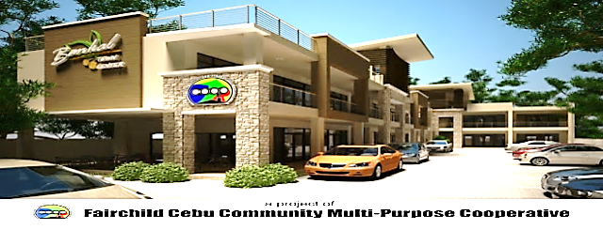
MAHAYAHAY, BANKAL , LAPU-LAPU CITY TEL. 494-3821 MAIN OFFICE: 341-2435 341-2456

GUEST REGISTRATION FORM

LAST NAME FIRST NAME MIDDLE NAME

NATIONALITY: PASSPORT NO.: CONTACT NO.:

HOME(COUNTRY OF ORIGIN) ADDRESS:
HOME CONTACT NO.:

CONTACT PERSON IN CASE OF EMERGENCY:
TELEPHONE NO. :

TG

CONTACT PERSON IN PHILIPPINES:
CONTACT NO.:

MALE FEMALE
NO. OF ADULT: NO. OF CHILDREN:

CHECK-IN

Intended CHECK-OUT

ROOM NO.

DATE:

DATE:

TIME:
TIME:

RENTAL ADVANCE:
RENTAL DEPOSIT:

BANKAL PLAZA CLERK:
SIGNATURE: DATE:

This Establishment is bound only exercise the ordinary diligence of a good father of the family. Hence, any claims of client for damages are precluded except those which result from an intentional or grossly negligent breach of obligation of this Establishment. Non-excepted claims against the Establishment are time-barred for a period one year after the cause of action arises.
Other guests names staying at the room:
The client shall bear the risk of damage or loss of any personal property, brought into the rooms or any premises of the Establishment.
During the occupancy of the rooms and use of any facilities of the Establishment, the clients, guests, representative, and assigns shall hold this Establishment free and harmless from any damage or liability or responsibility to any person or property arising out of or as a consequence of such occupation and use of facilities, save those arising directly from the fault and/or gross negligence of the Establishment.
By signing this information sheet, I hereby attest to the veracity of the information stated herein and voluntarily bind myself to the terms and conditions as herein provided.
GUEST’S SIGNATURE: DATE:

ATTACHMENT 2

BANKAL PLAZA ROOM CHECK-OUT CHECKLIST


ROOM NO.
ROOM NO. |  |  |  | AVAILABILITY |  | FUNCTIONAL |  | CLEARED FOR
APPLIANCES and FURNITURES |  |  |  | YES | NO | YES | NO | CHECK-OUT
TV & remote control
Center Table
Refrigerator
Shower Heater
Air-con unit & remote control
Electric Stove
Sofa Bed
Dining Table
Dining Chairs (4 pcs)
Mattress
Dresser
Wardrobe Closet Doors
Clothes Hanger
Overhang Cabinet Doors
Kitchen Cabinet drawers & doors
ELECTRICALS
Lightings (bulbs)
switches
outlets
PLUMBINGS
Sink and faucet
P-trap
Shower head & hose
Faucets
Toilet bowl
Toilet cover and Seat
Lavatory faucet & P-trap
LINENS
Bedsheet set (4 pc set)
Pillows (2 pc)
Towels
Date Check-In
Date Check-Out |  |  |  |  |  | Guest's Name

ATTACHMENT 3

DAILY CLEANING CHECKLIST


ACTIVITY |  |  |  |  |  |  | MON | TUE | WED | THUR | FRI | SAT
Sweeping Parking Area
Cleaning Ground Floor Hallways
 | Sweeping hallway floor
 | Mopping hallway floor
Cleaning Second Floor Hallways
 | Sweeping hallway floor
 | Mopping hallway floor
Cleaning Common Comfort Rooms
 | Cleaning lavatory with appropriate cleaner
 | Mopping/Scrubbing floor using appropriate cleaner
Cleaning Stainless Steel Railings
 | Apply All-purpose Shine on the railing
 | Use scrubbing pad/sandpaper on a rusty portion of railing
Cleaning of Rear Portion of the Building
 | Sweeping the area
 | Removing molds if necessary
Garbage Segragation
 | Separate biodegradable from non-biodegradable
 | in separate garbage bag
PERFORMED BY:
CHECKED BY:
Observations, Abnormalities, or issues observed:______________________________________________

ATTACHMENT 4

ROOM CLEANING CHECKLIST
ROOM NO. |  |  | ROOM CLEANING CHECKLIST |  |  |  | DATE
LIVING AREA |  |  | CLEANED | REMARKS |  |  | CHECKED BY | DATE
TELEVISION
CENTER TABLE
SOFA BED/SOFA
FLOOR
WINDOW
WALL
KITCHEN AREA |  |  | CLEANED | REMARKS |  |  | CHECKED BY | DATE
DINING TABLE
DINING CHAIRS
SINK AND FAUCET
KITCHEN TOP
ELECTRIC STOVE
KITCHEN CABINET
WALL CABINET
REFRIGERATOR
GARBAGE BIN
BEDROOM |  |  | CLEANED | REMARKS |  |  | CHECKED BY | DATE
AIRCONDITION UNIT
BED AND MATTRESS
PILLOW
WARDROBE CLOSET
DRESSER
DRESSER STOOL
DOOR AND DOORKNOB
FLOOR
WINDOW
TOILET AND BATH |  |  | CLEANED | REMARKS |  |  | INSPECTED BY | DATE
DOOR AND DOORKNOB
FLOOR
WALL
MIRROR
LAVATORY
FAUCET
SHOWER HEATER
SHOWER HEAD
SHOWER CURTAIN
WATER CLOSET
TISSUE/SOAP HOLDER
WINDOW
GARBAGE BIN
CLEANING PERFORMED BY: |  |  | _________________________________________________________________
 |  |  |  | Signature over Printed Name

ATTACHMENT 5

COLLECTION PROCEDURE FOR FCCMPC BUSINESS FACILITIES

- The Property custodian or the Security guard on duty will be designated as temporary collector for the coop for rent or payment proceeds
- The Property custodian or the Guard on duty shall issue a provisional receipt provided by the Coop institution. This receipt stub shall be tracked and controlled by the accounting department. Only one stub will be made available at any given time. (Replenishment shall be made once there are only 10 receipt leafs left)
- Guard on duty will secure and fill up a designated collection envelope and shall complete for the following information: Guard on duty will sign the envelope where designated.
3.1 Date
3.2 Amount received
3.3 Provisional Receipt number
3.4 Room number
3.5 Name of Renter
- Paid amount will be placed in the completely filled up envelope and signed accordingly by the property custodian or guard on duty
- The renter shall sign and validate the payment received by the guard on duty as designated in the section of the envelope at the sealed lip of the envelope fold and on the envelope itself
- Once completed, the the property custodian or the guard on duty will drop the sealed and signed envelope into a designated STAINLESS STEEL METAL MADE “SUGGESTION” securely locked BOX. (see picture below)
- After completing this process, the property custodian or the guard on duty will send a text message to the technical property custodian/business supervisor informing the payment date, amount and time
- The securely locked box shall and can only be opened by the technical property custodian supervisor. (Back up key will be safekept with the accounting department)
- The technical property custodian supervisor will open and count the money in front of the guard on duty to validate the envelope contents
- Once the content is validated, the guard on duty will log his name and signature on the envelope opened.
- The envelope copy and money will be endorsed to the accounting office for issuance of the official receipt. The envelope will be kept as proof and objective evidence tracking for the transaction
- The official receipt will be sent to the Bankal property renter for his reference and file
- This ends the procedure

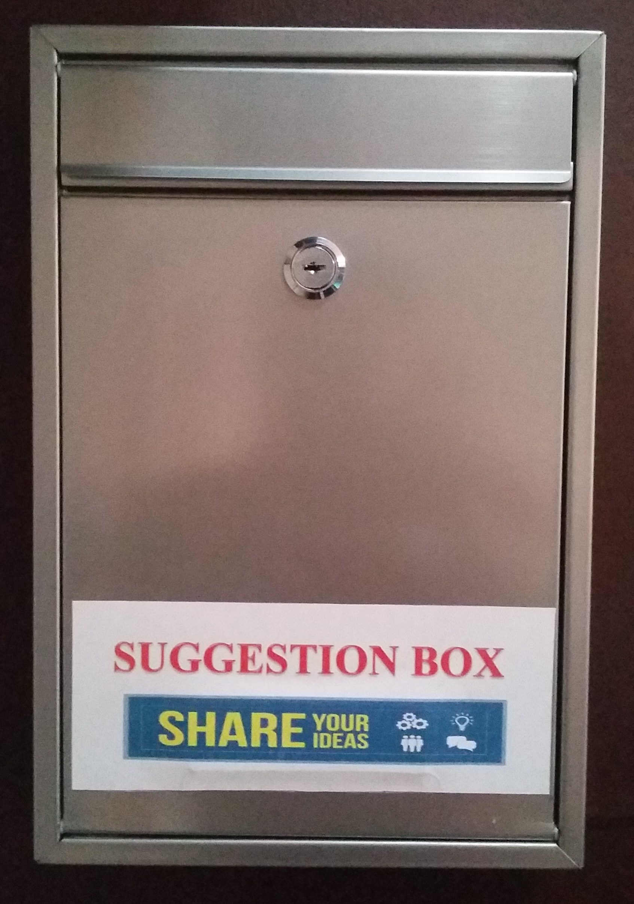

Sample Envelope Design

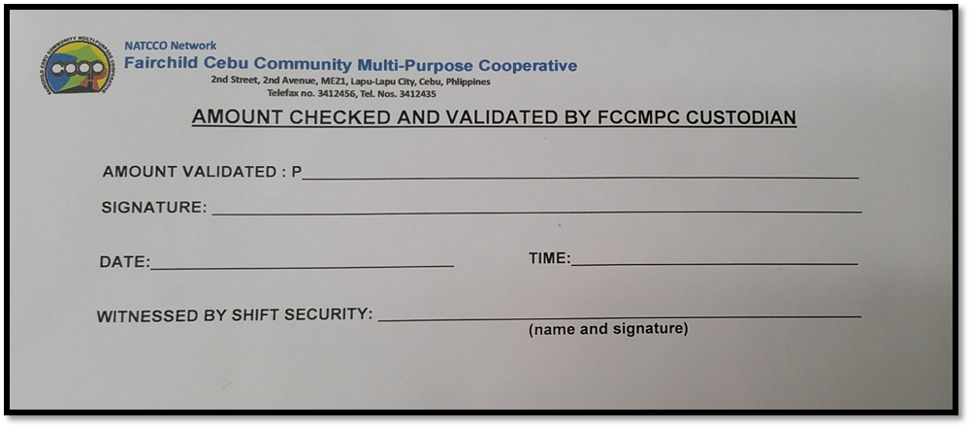

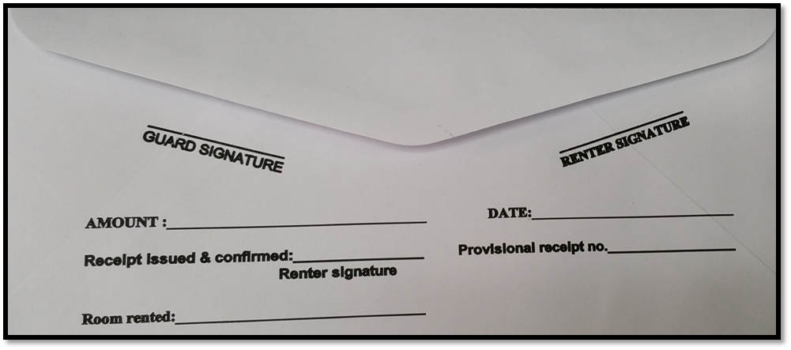

ATTACHMENT 6

CORRECTIVE ACTION REQUEST
(ALLIED SERVICES)

CORRECTIVE ACTION REQUEST (CAR)
(ALLIED SERVICES)
CAR #:__________

- PROBLEM STATEMENT
BANKAL PLAZA
BODYWORKS MASSAGE AND SPA
MARINA MALL
BANKAL PLAZA

OTHERS

DATE (PROBLEM REPORTED):_______________
PROBLEM:_____________________________
______________________________________
______________________________________
______________________________________
______________________________________
______________________________________

- ROOT CAUSE VERIFICATION AND ANALYSIS
- ______________________________________________________________
- ______________________________________________________________
- ______________________________________________________________

- CORRECTIVE ACTIONS
- _______________________________________________________________
- _______________________________________________________________
- _______________________________________________________________

CAR REQUESTED/REPORTED BY:__________________________ DATE:________________

ACTION MANAGED/PROCESSED BY:_______________________ DATE:________________

RECEIVED & APPROVED BY: _____________________________ DATE:________________

ATTACHMENT 7

QUARTERLY PREVENTIVE MAINTENANCE
